Who credited for the theory of Continental Drift?
Continental Drift is:…
PANGAEA | The Breakup of Pangaea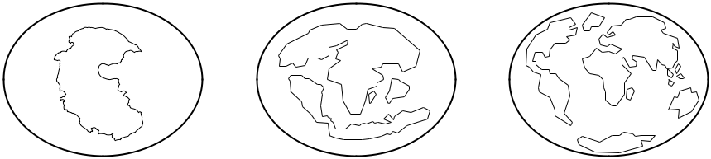

Alfred Wegener’s Evidence:
Evidence 1: | Evidence 2:
Description: | Description:
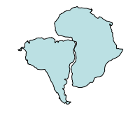 | 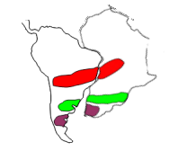
Evidence 3: | Evidence 4:
Description: | Description:
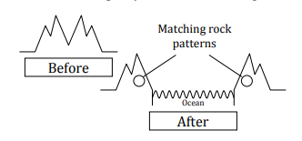 | 